**Integration Testing Document**

Mainframe Tour Project

Author: Kondreddy Sumanth Kumar Reddy  
**Mainframe ID:** OZA136  
Project Name: Mainframe Project on Tour

**TABLE OF CONTENTS**

**1.** **Introduction** 3

**2.** **Test Environment** 3

**3.** **Integration Test for Tour Project** 3

**3.1 Test Case 1: SPUFI Operations** 3

**3.2 Test Case 2: Discount Calculation and SEASON_DISCOUNT Population** 6

**3.3 Test Case 3: NULL Value Processing** 7

**4. Conclusion** 9

**5. Version History** 9

## **Introduction**

This Integration Test Plan focuses on testing the interactions between various components of the Mainframe Tour Project, including database tables, SPUFI components, COBOL programs, and JCL components. The plan ensures that all system components work together seamlessly to process tour details, calculate discounts, and generate appropriate outputs.

## **Test Environment**

The integration testing will follow a bottom-up approach:

1. **Tables**: TOUR_DETAILS and SEASON_DISCOUNT
2. **Test Data**: Sample tour records
3. **Programs**: TOUR COBOL program
4. **JCL**: CBLDDBCMP, CBLDDBBND, CBLDDBRUN
5. **SPUFI**: TABLE1, TABLE2, INSERT1, JOIN, SELECT
6. **DCLGEN**: TOURDET, SEASDIS

## **Integration Test for Tour Project**

### **3.1 Test Case 1: SPUFI Operations**

**Objective:** Verify successful execution of SQL queries using SPUFI.

**Steps:**

* Creating Tables:
  + TOUR_DETAILS TABLE (TABLE1)

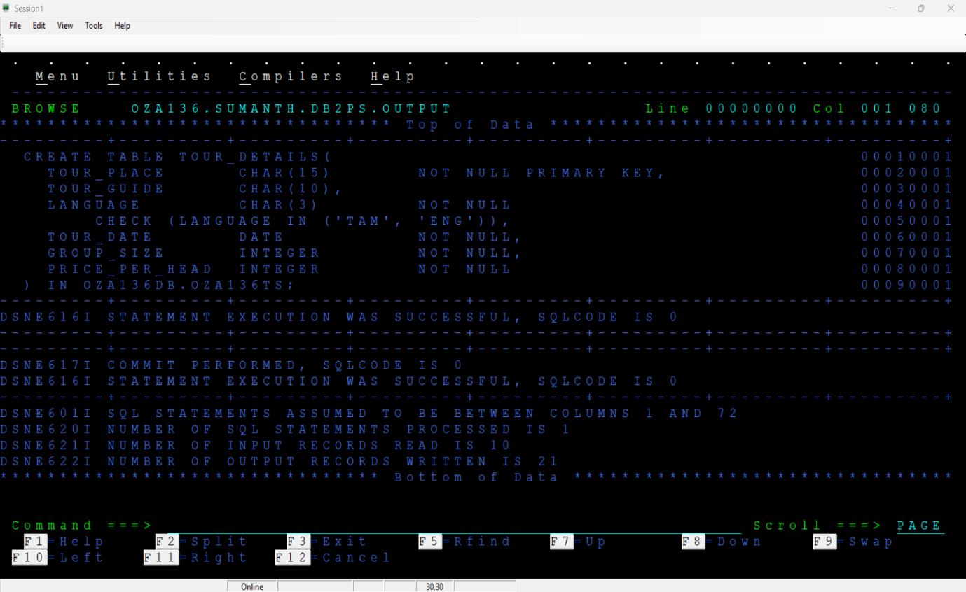

* + SEASON_DISCOUNT TABLE (TABLE2)

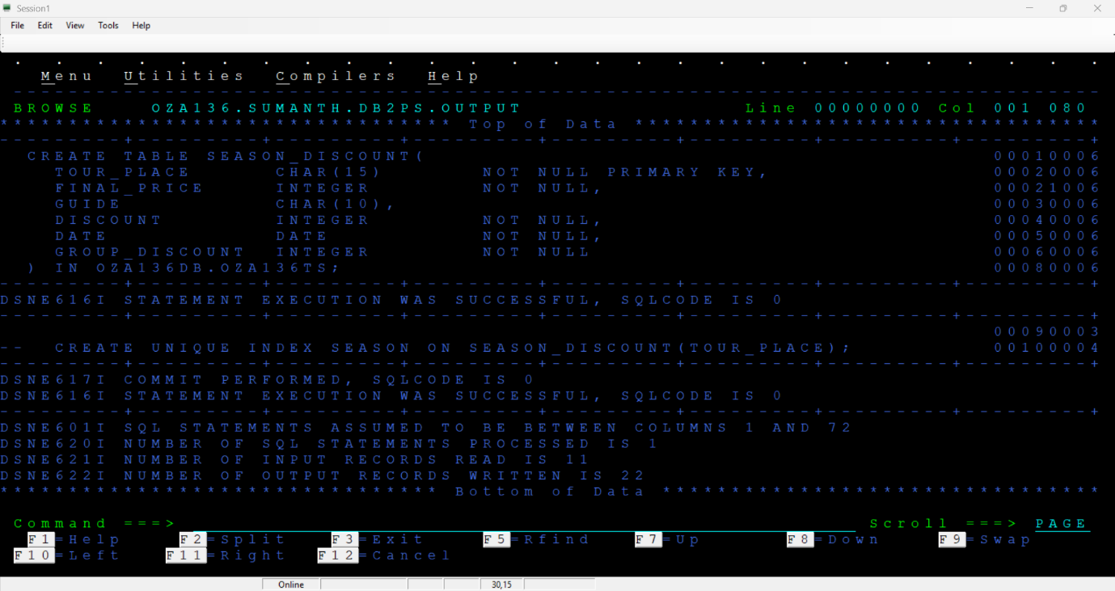

* **Inserting Sample Data:** 
  + TOUR_DETAILS TABLE (INSERT1)

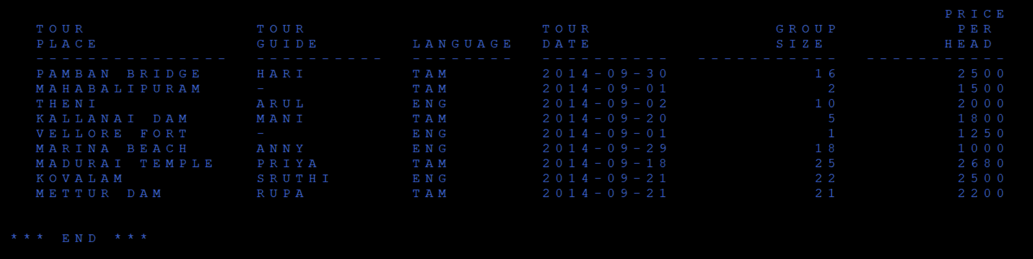

* **Displaying Data using SQL Query:** 
  + Select query to fetch the records with LANGUAGE as ENG and GROUP_SIZE greater than 10 from the two tables TOUR_DETAILS and SEASON_DISCOUNT using LEFT OUTER JOIN operation. Order the resultant table by TOUR_PLACE. Expected fields from the query are TOUR_PLACE, TOUR_GUIDE, LANGUAGE, TOUR_DATE, GROUP_SIZE, GROUP_DISCOUNT.

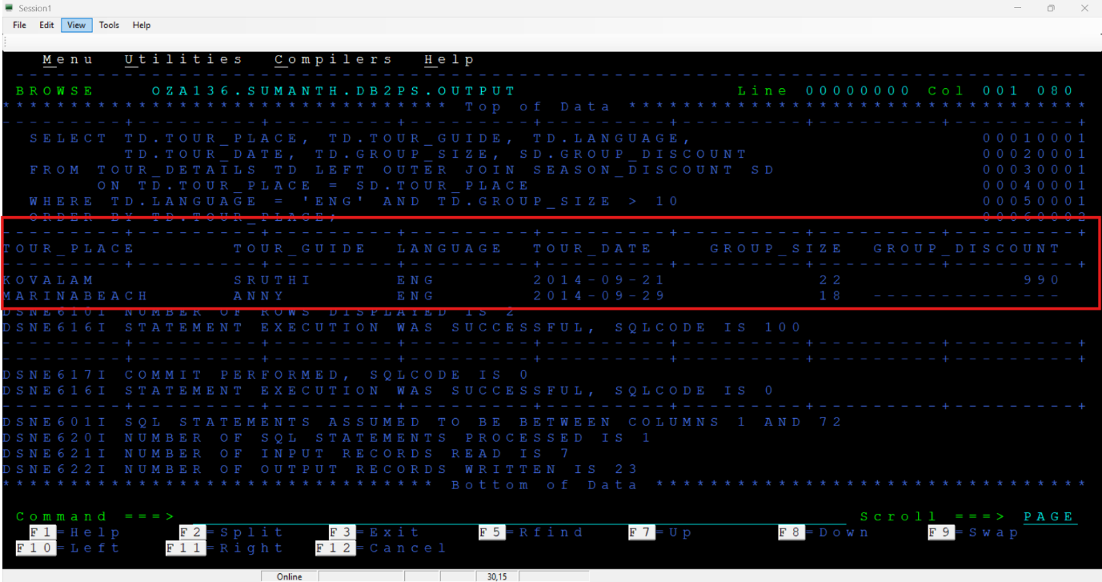

* + Select query to fetch all the records from SEASON_DISCOUNT with which record is having DISCOUNT less than or equal to 20 with converting the TOUR_PLACE & GUIDE to lower case.

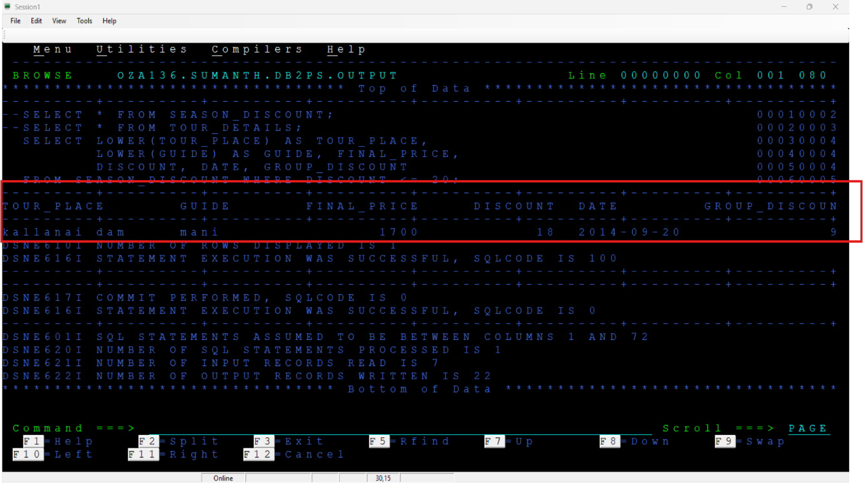

**Results:** All SPUFI operations executed successfully.

**Conclusion:** SPUFI operations were executed successfully, and the test case passed.

### **3.2 Test Case 2: Discount Calculation and SEASON_DISCOUNT Population**

**Objective:** Verify that discount calculations are correctly performed and results are inserted into SEASON_DISCOUNT and OUTTOUR file contains correct records.

**Program:**

* Cobol Program Name: TOUR
* Functionality:
  + Fetch data from TOUR_DETAILS table
  + Process records with NULL TOUR_GUIDE values
  + Calculate discounts based on GROUP_SIZE and LANGUAGE
  + Apply appropriate FINAL_PRICE adjustments
  + Write the processed records to output file

**Pre-Requisites:**

* Input Table:
  + TOUR_DETAILS



**Result:**

* Output File:

OZA136.SUMANTH.TOUR.PS (OUTTOUR)

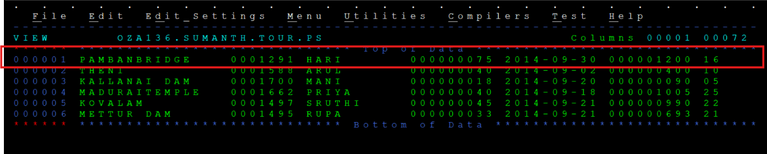

SEASON_DISCOUNT Table:

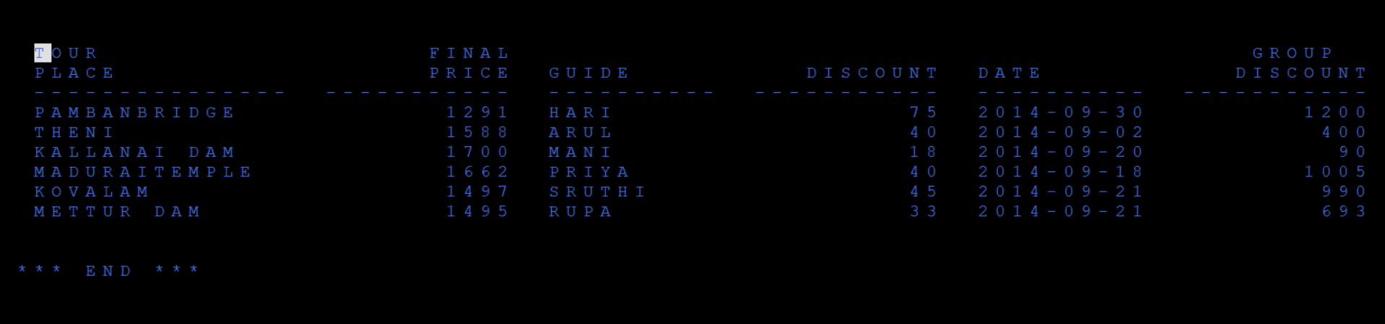

**Test Data Processing:**

* Discount calculations were correctly applied based on GROUP_SIZE and LANGUAGE
* FINAL_PRICE adjustments were correctly applied based on DISCOUNT ranges

**Results:** Discounts correctly calculated based on GROUP_SIZE rules. FINAL_PRICE calculated correctly based on DISCOUNT ranges. GROUP_DISCOUNT properly calculated. Records successfully inserted into SEASON_DISCOUNT. OUTTOUR file contains correct records.

**Conclusion:** The discount calculations are correctly performed and results are inserted into SEASON_DISCOUNT And OUTTOUR file contains correct records. Test case is passed.

### **3.3 Test Case 3: NULL Value Processing**

**Objective:** Verify that the system properly handles NULL TOUR_GUIDE values across components.

**Program:**

* Cobol Program Name: TOUR
* Functionality:
  + Fetch data from TOUR_DETAILS table
  + Process records with NULL TOUR_GUIDE values
  + Write the processed records to output file

**Pre-Requisites:**

* Input Table:
  + TOUR_DETAILS



**Result:**

* Output File:
  + OZA136.SUMANTH.ODEL.PS (OUTODEL)

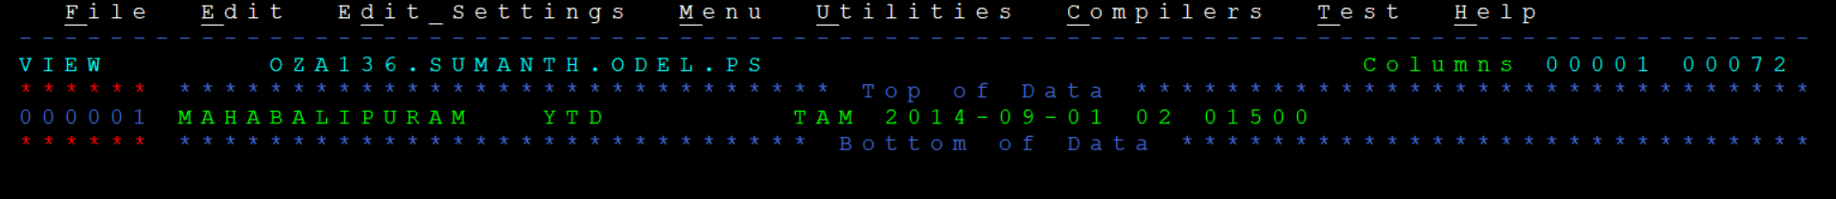

* TOUR_DETAILS:

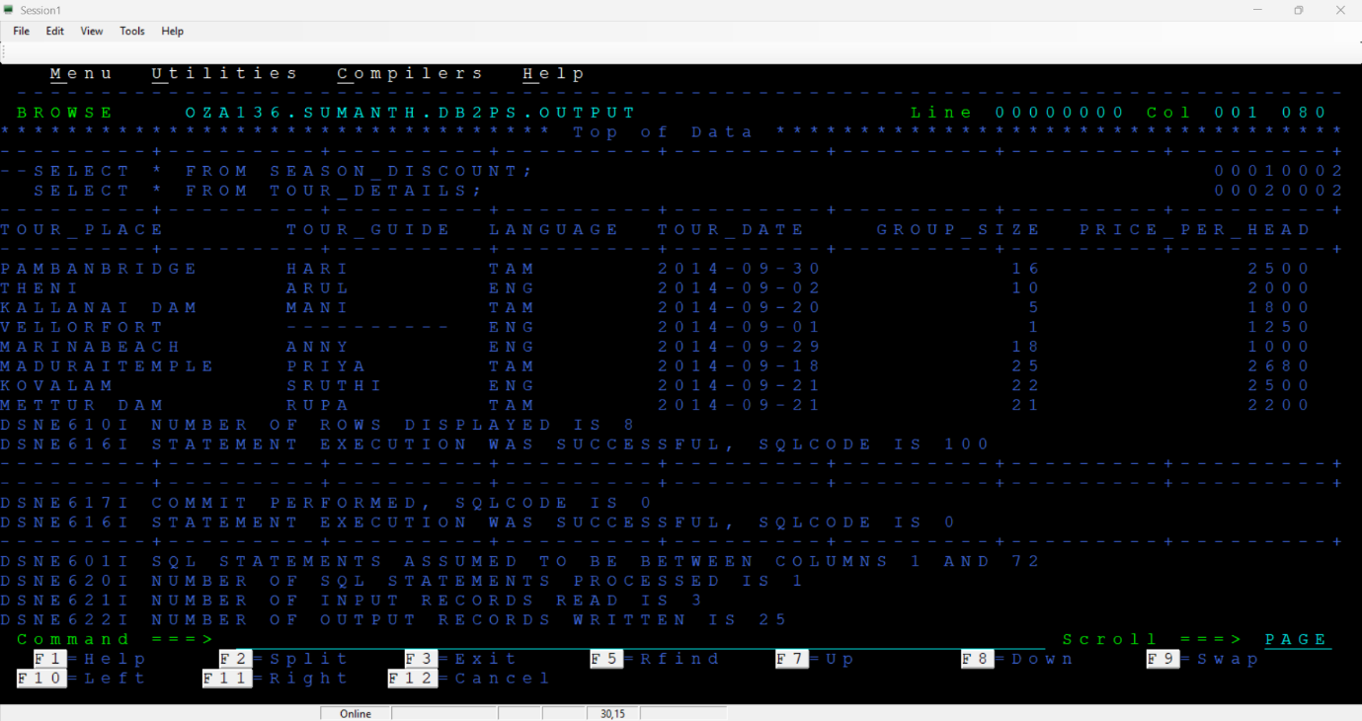

**Test Data Processing:**

* Check OUTODEL file for records with NULL TOUR_GUIDE
* Verify these records are deleted from TOUR_DETAILS
* Confirm 'YTD' replacement functionality

**Results:** Records with NULL TOUR_GUIDE and meeting criteria (GROUP_SIZE > 1) deleted from TOUR_DETAILS. OUTODEL file contains correct records.

**Conclusion:** NULL value processing handled successfully, and the test case passed.

## **4. Conclusion**

* Output files (OUTTOUR and OUTODEL) generated as per the requirements of the Tour Discount Processing System.
* Integration tests confirm that the COBOL-DB2 batch process accurately calculates discounts and interacts with the DB2 database.
* System correctly identifies and processes records with NULL TOUR_GUIDE values.
* Discount calculations work correctly for all specified ranges.

## **5. Version History**

|  |  |  |  |
| --- | --- | --- | --- |
| **Version** | **Date** | **Author** | **Changes Made** |
| 1.0 | 20-March-2025 | Sumanth Kumar Reddy | Initial Draft Created |
| 1.1 | 20-March-2025 | Sumanth Kumar Reddy | Added Screenshots |
| 1.2 | 21-March-2025 | Pranchan Biswas | Sign-off and Final review |